FOR YOUR EYES ONLY – THIS DOCUMENT CONTAINS CONFIDENTIAL INFORMATION.

GIVEN TO PATRICK SIRICH, CASPER FROST ANDERSEN, CHRISTIAN MØLLER STRUNGE & MATTHIAS SKOU. CAN ONLY BE VIEWED BY THEM AND THOSE PARTICIPATING IN THIS SPECIFIC EXAM.

DISTRIBUTION OF THIS DOCUMENT IS FORBIDDEN.

TheNext – Helping banks

becoming a Customer Centric Orchestrator of eco-systems – first!

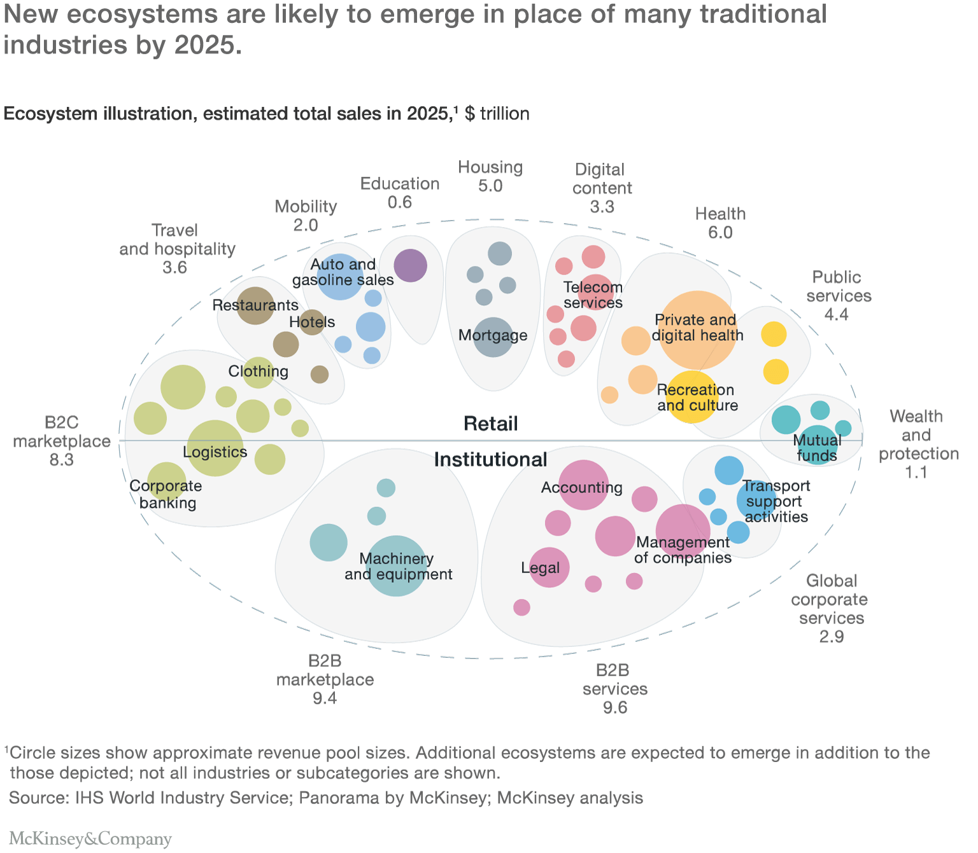

Jan Sirich | TheNext ApS | December 2018

# Preface

## Threats and opportunities

The frontpage picture of this memo, illustrates McKinsey’s suggestion of today’s industries with clear boundaries that may change into [a world of sectors without borders](https://www.mckinsey.com/business-functions/mckinsey-analytics/our-insights/competing-in-a-world-of-sectors-without-borders), quote: “*… we believe an increasing number of industries will converge under newer, broader, and more dynamic alignments: Digital ecosystems. A world of ecosystems will be a highly customer-centric model, where users can enjoy an end-to-end experience for a wide range of products and services through a single access gateway, without leaving the ecosystem …”.*

There is no banking eco-system in McKinsey’s forecast! We claim that part of the winning formula is also the ability to create a coherent UX and UI experience and can service their customers’ individual interests with thorough understanding of their individual needs, dreams and preferences, i.e. in an eco-system context beyond banking services.

Today, banks strongest assets are the huge and loyal customer bases (very high switching cost), distribution position, systemic position, and customer trust. But as McKinsey suggests it may change, and it could even transform the existing banking business model to new models (e.g. platform economy).

It’s TheNext’s mission to help incumbent banks becoming an eco-system orchestrator, so they can keep their position as a value creator towards customers.

So, you should partner up with TheNext and explore “the new opportunities” in a setting outside your current banking setup.

TheNext will orchestrate establishing, evolving and running the eco-system of content partners, as well as being the technology provider, enabling all this to happen.

This is radical thinking for some incumbent banks, but through several conversations with various banks in Europe, the timing to start exploring these new opportunities seems to be right.

Jan Sirich, CEO and Founder of TheNext

+45 4058 8712

[Jan.sirich@thenext.dk](mailto:Jan.sirich@thenext.dk)

www.thenext.dk

TheNext ApS, CVR: 39378574

Hornbækgårdsvej 15,

3100 Hornbæk, Denmark

# Appendix a) Roles and operational framework

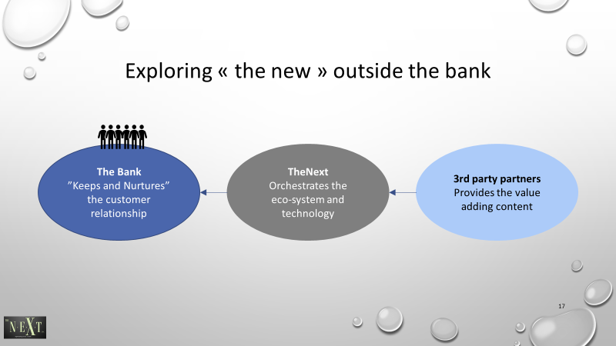

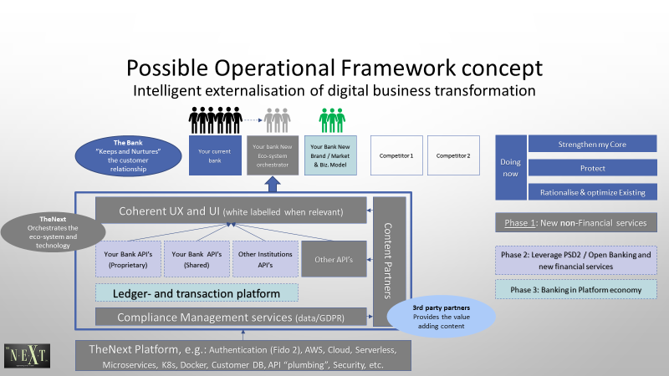

# Appendix b) About TheNext and Jan Sirich

## TheNext mission, Vision and position

It’s TheNext’s mission to help banks becoming an eco-system orchestrator, so they can keep their position as a value creator towards customers, addressing the risk of becoming a systemic[1] important infrastructure provider / product pusher of traditional banking products and services only. Given the technological evolution, political wish for competition in banking, customers’ increased digital savviness and incumbent banks’ lacking abilities to transform to new potential business models (e.g. platform economy and api-fication), there is now a tiny open window gap for new entrants, but soon it may be a huge open door impossible to shut or catch up with for the incumbents who then gradually become disintermediated.

TheNext’s vision goes beyond “just” the eco-system orchestration, as TheNext also wants to include financial services into the eco-system orchestration leveraging Open Banking (PSD2 etc.) and xTech integration opportunities (payments, cards, financing etc.). TheNext bases all this on a core banking platform thus TheNext ultimately will be able to offer banking services end-to-end from UX/IU all the way through transaction and ledger management to compliance management and reporting, all fully detached from current legacies and designed for new business models.

TheNext’s mission and vision is rooted in the overall ambition of improving customer experiences through value adding innovations leveraging the various “new digital” opportunities and partnering up with 3rd parties in general.

TheNext’s overarching design and business model principle is *“€ flows when customer value is created”*, which is rooted in the Platform business model and desire for being outside-in customer centric in all design.

TheNext is a company offering services globally in the financial industry and You can buy services and deliveries through normal consulting agreement (e.g. PoC) or through a Corporate Ventures investment for larger engagement and strategic positioning.

TheNext partners with TCS as primary technology provider and has through TCS’ numerous patented and IP-protected solutions and the COIN network access to global competence and connectivity.

TheNext is currently solely funded by Founder and CEO Jan Sirich, but that will change over time through various investment rounds.

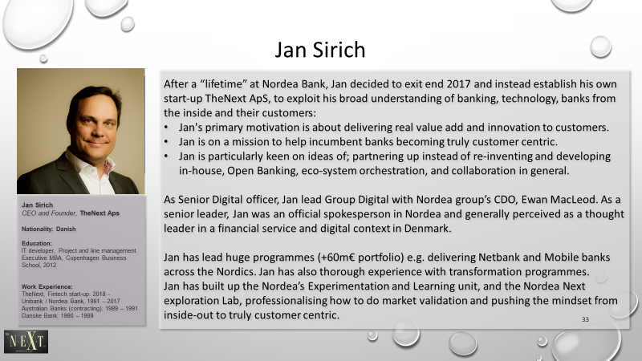

1. Societal growth, consumer protection and financial stability